ish¿u ysñlï weúßKs $ All Rights Reserved

St. Peter's College

St. Peter's College

St. Peter's College

புனித பேதுரு கல்லூரி

புனித பேதுரு கல்லூரி

புனித பேதுரு கல்லூரி

புனித பேதுரு கல்லூரி

புனித பேதுரு கல்லூரி

புனித பேதுரு கல்லூரி

புனித பேதுரு கல்லூரி

புனித பேதுரு கல்லூரி

Ydka; mS;r úÿy,

Ydka; mS;r úÿy,

Ydka; mS;r úÿy,

Ydka; mS;r úÿy,

Ydka; mS;r úÿy,

Ydka; mS;r úÿy,

Ydka; mS;r úÿy,

Ydka; mS;r úÿy,

Ydka; mS;r úÿy,

Ydka; mS;r úÿy,

St. Peter's College

St. Peter's College

St. Peter's College

St. Peter's College

St. Peter's College

St. Peter's College

St. Peter's College

St. Peter's College

St. Peter's College

St. Peter's College

புனித பேதுரு கல்லூரி

புனித பேதுரு கல்லூரி

புனித பேதுரு கல்லூரி

புனித பேதுரு கல்லூரி

புனித பேதுரு கல்லூரி

புனித பேதுரு கல்லூரி

புனித பேதுரு கல்லூரி

புனித பேதுரு கல்லூரி

Ydka; mS;r úÿy,

Ydka; mS;r úÿy,

Ydka; mS;r úÿy,

Ydka; mS;r úÿy,

Ydka; mS;r úÿy,

Ydka; mS;r úÿy,

Ydka; mS;r úÿy,

Ydka; mS;r úÿy,

Ydka; mS;r úÿy,

Ydka; mS;r úÿy,

St. Peter's College

St. Peter's College

St. Peter's College

St. Peter's College

St. Peter's College

St. Peter's College

St. Peter's College

41

E

**I,II**

**fmrÈ. ix.S;h**

**Western Music**

**meh**

**Hour**

**02**

**08 fY%aKsh – fojk jdr we.hsu - 2023**

***Grade 08 – Second Term Examination - 2023***

Ydka; mS;r úÿy, - fld<U 04

புனித பேதுரு கல்லூரி, கொழும்பு 4

***St. Peter's College - Colombo 04***



Name:……………………………………………………….. Class:………. No:……….

**Paper I**

**Answer all the questions.**

² **Underline the most suitable answer.**

01. A plucked string instrument, widely used in folk music, pop music and jazz music. Pop bands and Calypso bands also use this instrument.

The above mentioned instrument can be,

i. Violin ii. Viola iii. Cello iv. Guitar

02. Who is regarded as the “Father of the symphony”?

i. Bach ii. Haydn iii. Mozart iv. Beethoven

03. Which is correct about Mozart?

i. 1756 - 1791 ii. 1732 - 1809 iii. 1685 - 1750 iv. 1770 - 1827

04.

The given guitar chord is,

i. C major ii. G major

iii. F major iv. D major

05. Which pair of bird call is musical and is like that of an oboe?

i. Koel , Oriole ii. Magpie , Crow

iii. Barbet , Koel iv. Oriole , Grackle

06. The letter name of this note is,

|  |
| --- |
|  |
|  |
|  |
|  |

i. G ii. G flat

iii. A flat iv. A

07. The correct time signature for four quaver beats in a bar is,

i. ii. iii. iv.

08. The total value of this bar is,

i. ii.

iii. iv.

09. Which of the following is the incorrect statement about ‘Rhythm’,

i. Simple times have undotted beats.

ii. in compound times each beat is divided to two pulses.

iii. is two dotted crotchet beats in a bar.

iv. Both simple and compound times have duple, triple and quadruple rhythms.

10. A chromatic semitone above G sharp is,

i. G natural ii. A

iii. G double sharp iv. G double flat

11. A diatonic semitone below A flat,

i. A double flat ii. A double sharp

iii. G iv. F sharp

12. A tone above G sharp is,

i. A sharp ii. A double sharp

iii. A iv. G flat

13. A tone below F is,

i. E ii. E flat iii. G iv. F sharp

14. The note which has only two enharmonical names is,

i. F sharp ii. B flat iii. A sharp iv. G sharp

15. The number of lines in the great staff is,

i. 10 ii. 11 iii. 5 iv. 4

16. The major key having five flats is,

i. B flat major ii. D flat major

iii. E flat major iv. A flat major

17. Pianissimo is,

i. Very soft ii. Soft

iii. Moderately soft iv. Very loud

18. The side drum is also called the,

i. Bass drum ii. Kettle drum

iii. Snare drum iv. Congo drum

19. The number of semitones between C – G interval,

i. 7 ii. 6 iii. 8 iv. 5

20. The number of notes in a major scale would be,

i. 7 ii. 8 iii. 3 iv. 2

**(20 Marks)**

**Paper II**

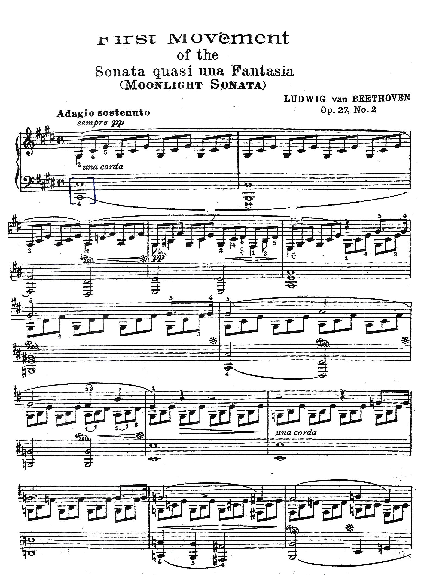

Answer the following questions from the extract given bellow.

01. Compulsory 1st question.

a). The composer of the given extract is Beethoven. Write the full name of this composer.

__________________________________________

b). To which period does this composition belong?

__________________________________________

c). Name the nationality of this composer.

__________________________________________

d). Name a contemporary composer.

__________________________________________

e). Name an opera written by Beethoven.

__________________________________________

f). Describe the time signature C.

__________________________________________

g). What does PP mean?

__________________________________________

h). What is the letter name of the first note in bar l (treble stave)

__________________________________________

i). Name the bracketed interval.

__________________________________________

j). What is the irregular note pattern given in this melody. (Underline the answer)

Duplet / Triplet

**(10 Marks)**

02. a. Write beat notes according to the given time signatures.

|  |
| --- |
|  |
|  |
|  |
|  |

b. Put the correct time signature.

|  |
| --- |
|  |
|  |
|  |
|  |

c. Fill with the correct rest(s)

|  |
| --- |
|  |
|  |
|  |
|  |

d. Add bar lines.

|  |
| --- |
|  |
|  |
|  |
|  |

|  |
| --- |
|  |
|  |
|  |
|  |

**(10 Marks)**

03. a. Name these intervals

|  |
| --- |
|  |
|  |
|  |
|  |

b. Write the correct interval.

|  |
| --- |
|  |
|  |
|  |
|  |

c. Name the keys which has the given key signatures.

|  |
| --- |
|  |
|  |
|  |
|  |

_______________________________________________________

d. Write these scales.

1. D major scale ascending in treble with key signature, as crotchets.

|  |
| --- |
|  |
|  |
|  |
|  |

2. major scale descending in bass as minims, with accidentals.

|  |
| --- |
|  |
|  |
|  |
|  |

**(10 Marks)**

04. a. Name these Sri Lankan drums

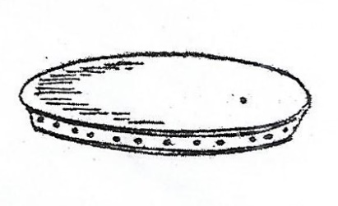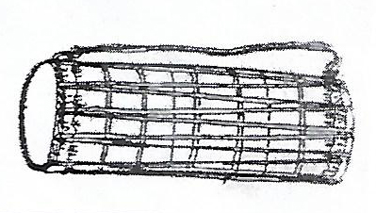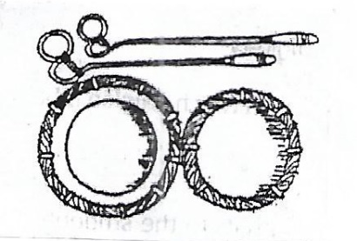

___________________ ___________________ ___________________

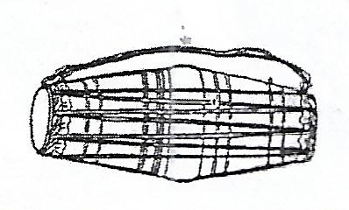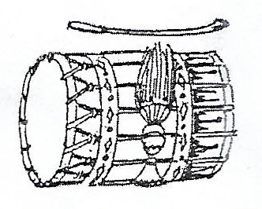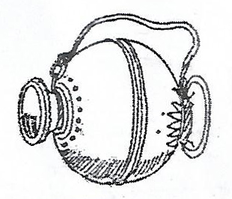

___________________ ___________________ ___________________

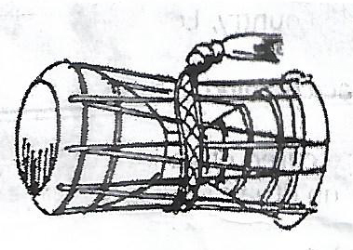

___________________

b. Write short answers.

1. The main drum used to accompany dance sequences in all Kandyan rituals _________________

2. The drum which is also called Pokuru beraya or Cluster of drums _________________

3. The drum which is generally used to accompany harvesting songs and folk dances _________________

4. An essential drum used in the Buddhist ceremonies and Hewisi performances played with one hand and one stick _________________

5. The main drum used for singing of Prashasthi _________________

**(10 Marks)**